Program No. 01. >> Simple Bar Chart Visualization
Objective: To understand basic data visualization using bar charts.
Tasks:
- Create a simple bar chart using student marks or sales data
- Explain what the bar chart represents
Outcome: Students will be able to visualize and compare categorical data using bar charts.
Tools Used: Python, NumPy, Matplotlib
Dataset: Uncleaned_Student_Dataset.csv

Script/Code:
# Import Required Libraries
import pandas as pd
import numpy as np
import matplotlib.pyplot as plt

# Load the Given Student CSV Dataset
file = "Uncleaned_Student_Dataset.csv"
df = pd.read_csv(file)
df.head()

df_bar = df[['department', 'sgpa']]

Output:

Thank You!!
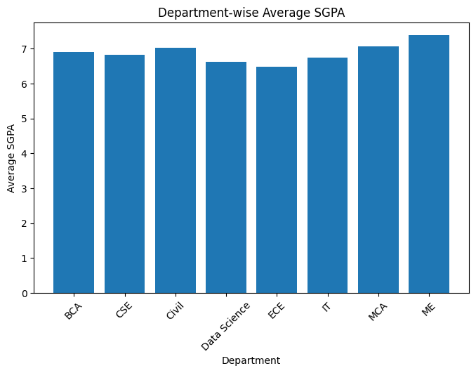
Program No. 02. >> Line Chart for Time-Based Data
Objective: To represent trends in time-based data.
Tasks:
- Draw a line chart to represent monthly attendance or sales data
- Interpret trends over time
Outcome: Students will understand trend analysis using line charts.
Tools Used: Python, Matplotlib

Script:

Output:

Program No. 03. >> Data Representation vs Data Presentation
Objective: To differentiate between data representation and data presentation.
Tasks:
- Represent the same dataset using at least two different chart types
- Compare clarity and interpretation
Outcome: Students will be able to choose appropriate visualization techniques.
Tools Used: Python, Pandas, Matplotlib

Script:

Output:

Program No. 04. >> Donut Chart and Purpose of Visualization
Objective: To understand the purpose of data visualization.
Tasks:
- Identify visualization goals for a dataset
- Create a donut chart to represent proportional data
Outcome: Students will understand how visualization supports decision-making.
Tools Used: Python, Matplotlib

Script:

Output:

Program No. 05. >> Seven Stages of Data Visualization
Objective: To study the complete data visualization process.
Tasks:
- Explain the seven stages of data visualization using a simple example
Outcome: Students will understand the end-to-end visualization workflow.
Tools Used: Python, MS Word / Notebook (for explanation)

Script: Uncleaned_Student_Dataset
Attributes include: student_id, roll_number, department, program, academic_year, course_code, attendance_percentage, internal_marks, external_marks, sgpa, gender, age, study_hours
Note: The dataset contains:
- Missing values
- Inconsistent entries (e.g., gender formats, study_hours as text)
- Blank fields: This makes it suitable for explaining the complete visualization workflow.
Seven Stages of Data Visualization
1. Data Collection: Data is collected from raw sources without modification.
Example: Student academic and demographic records collected from different departments and stored as Uncleaned_Student_Dataset.

2. Data Cleaning: Incorrect, missing, and inconsistent data is identified and handled.
Example:
- Removing or filling missing sgpa values
- Converting gender values like M, Male, female into a standard format
- Replacing text values like five in study_hours with numeric values

3. Data Processing: Cleaned data is organized and transformed into usable form.
Example:
- Calculating total marks = internal + external
- Categorizing attendance as low, medium, or high
- Creating age groups

4. Data Analysis: Patterns and relationships are explored in the processed data.
Example:
- Analyzing relationship between study_hours and sgpa
- Comparing performance across departments
- Identifying students with low attendance and low marks
5. Data Visualization: Graphs and charts are created to represent the analyzed data.
Example:
- Bar chart for department-wise student count
- Pie or donut chart for gender distribution
- Line chart showing academic year trends

6. Interpretation: The visual outputs are examined to derive meaningful insights.
Example:
- Higher study hours generally lead to better SGPA
- Some departments have consistently higher attendance
- Certain programs need academic support

7. Decision Making: Final decisions are taken based on interpreted insights.
Example:
- Planning remedial classes
- Improving attendance policies
- Allocating faculty based on department strength

Outcome: Students understand the end-to-end data visualization workflow, from an uncleaned dataset to insight-driven decision making.
Output:

Program No. 06. >> Basic Visualization Using Any Tool
Objective: To gain hands-on experience with visualization tools.
Tasks:
- Create one basic visualization using Excel / Google Sheets / Tableau / Power BI
Outcome: Students will be able to create basic charts using visualization tools.
Tools Used: Excel / Google Sheets / Tableau / Power BI / Python

Script:
#Bar Chart – Department-wise Average Attendance
- Steps to Create Visualization in Excel
- Open Microsoft Excel
- Import the Uncleaned_Student_Dataset.xlsx
- Make formatting:
  - Fit Column and Width: Alt + H + O + I, Alt + H + O + A
  - Formatting Data: Select row1 ‘Ctrl + B’, Alt + H + B +A
- Select the columns:
  - department
  - attendance percentage
- Use Insert → Pivot Table
  - Rows: Department
  - Values: Average of Attendance Percentage
- Select the Pivot Table
- Go to Insert → Bar Chart
- Add:
  - Chart Title
  - X-axis: Department
  - Y-axis: Average Attendance (%)

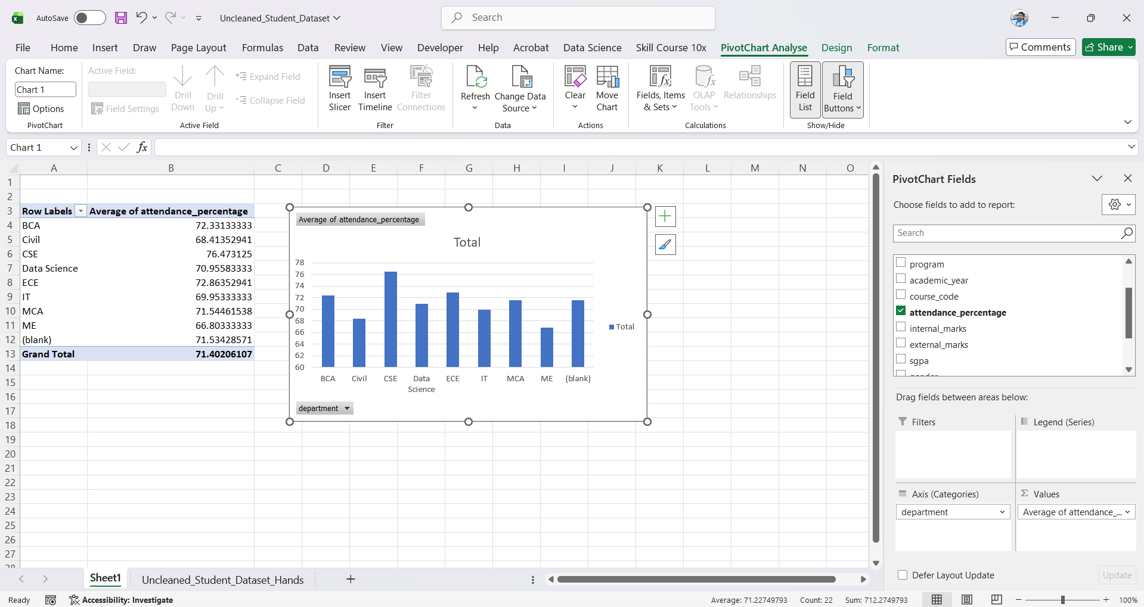
Output:

Program No. 07. >> Area Chart for Time-Series Data
Objective: To visualize cumulative data over time.
Tasks:
- Create an area chart for yearly profit or rainfall data
Outcome: Students will understand growth patterns using area charts.
Tools Used: Python, Matplotlib

Script:
import pandas as pd
import matplotlib.pyplot as plt

# Load dataset
df = pd.read_csv("MMDU_Student_Performance.csv")

# Select required columns
data = df[['academic_year', 'percentage']]

# Remove missing values
data = data.dropna()

# Convert academic_year to string (for plotting)
data['academic_year'] = data['academic_year'].astype(str)

# Calculate average percentage per academic year
yearly_avg = data.groupby('academic_year')['percentage'].mean().sort_index()

# Create area chart
plt.figure(figsize=(8, 5))
plt.fill_between(
yearly_avg.index,
yearly_avg.values,
alpha=0.7
)

# Labels and title
plt.xlabel("Academic Year")
plt.ylabel("Average Percentage")
plt.title("Area Chart Showing Average Student Performance Over Academic Years")

# Display chart
plt.show()
Output:

Program No. 08. >> Scatter Plot Analysis
Objective: To study relationships between two variables.
Tasks:
- Draw a scatter plot for study hours vs marks
- Analyze correlation
Outcome: Students will identify relationships between variables.
Tools Used: Python, Matplotlib

Script:

Output:

Program No. 09. >> Pivot Table and Pivot Chart
Objective: To summarize and analyze data.
Tasks:
- Create a pivot table
- Generate a pivot chart from the dataset
Outcome: Students will perform grouped data analysis efficiently.
Tools Used: Python, Pandas, Matplotlib / Excel

Script:

Output:

Program No. 10. >> Tree Map Visualization
Objective: To visualize hierarchical and categorical data.
Tasks:
- Design a tree map for department-wise student count
Outcome: Students will understand hierarchical data visualization.
Tools Used: Python, Squarify, Matplotlib

Script:

Output:

Program No. 11. >> Node-Link Diagram
Objective: To visualize relationships between entities.
Tasks:
- Draw a node-link diagram showing relationships (e.g., friends in a class)
Outcome: Students can build and train basic neural networks.
Tools Used: Python, NetworkX, Matplotlib

Script:

Output:

Program No. 12. >> Heatmap for Correlation Analysis
Objective: To analyze correlation among numerical variables.
Tasks:
- Create a color-coded correlation matrix (heatmap)
Outcome: Students will analyze relationships among multiple variables.
Tools Used: Python, Pandas, Seaborn, Matplotlib

Script:

Output:

Practical 13: >> Multi-Variable Time-Series Visualization
Objective: To analyze multiple variables over time.
Tasks:
- Create a time-series visualization with multiple variables
- Analyze observed patterns
Outcome: Students will interpret multi-dimensional time-series data.
Tools Used: Python, Matplotlib

Script:

Output:

Thank You!

Program No. 14. >> Text Data Visualization
Objective: To visualize textual data.
Tasks:
- Count word frequency from a paragraph
- Plot text visualization
Outcome: Students will understand basic text visualization techniques.
Tools Used: Python, WordCloud, Matplotlib

Script:

Output:

Program No. 15. >> Multivariate Chart Visualization
Objective: To visualize more than two variables simultaneously.
Tasks:
- Create a multivariate chart using marks in three subjects
Outcome: Students will analyze complex datasets visually.
Tools Used: Python, Matplotlib

Script:

Output:

Program No. 16. >> Case Study on Visualization
Objective: To study real-life applications of visualization.
Tasks:
- Analyze a small case where visualization improves understanding
Outcome: Students will appreciate visualization in real-world decision-making.
Tools Used: Python, Jupyter Notebook / MS Word.

Script:

Output:

Program No. 17. >> Live-like Data Visualization
Objective: To simulate real-time data visualization.
Tasks:
- Create a live-like visualization using continuously updated values
Outcome: Students will understand real-time monitoring concepts.
Tools Used: Python, Matplotlib, Time module.

Script:

Output:

Program No. 18. >> Visualization Best Practices
Objective: To learn principles of effective visualization.
Tasks:
- Write rules or best practices for good visualizations with examples
Outcome: Students will design meaningful and clear visualizations.
Tools Used: MS Word / Notebook, Python (examples).

Script:

Output:

Program No. 19. >> Open and Closed Port Visualization
Objective: To visualize basic network security data.
Tasks:
- Create a chart showing open and closed ports
Outcome: Students will understand visualization of network status.
Tools Used: Python, Matplotlib.

Script:

Output:

Program No. 20. >> Firewall Log Visualization
Objective: To identify suspicious traffic using visualization.
Tasks:
- Visualize firewall log data
- Identify suspicious traffic patterns
Outcome: Students will detect anomalies using visual analysis.
Tools Used: Python, Pandas, Matplotlib.

Script:

Output:

Program No. 21. >> Intrusion Detection Visualization
Objective: To analyze intrusion detection logs.
Tasks:
- Design intrusion detection log visualization
- Highlight possible attacks
Outcome: Students will understand visualization in cybersecurity.
Tools Used: Python, Pandas, Matplotlib.

Script:

Output:

Program No. 22. >> Sentiment Analysis Visualization
Objective: To analyze sentiment from social media data.
Tasks:
- Implement sentiment analysis on live tweet data using Python libraries
Outcome: Students will apply NLP techniques for visualization.
Tools Used: Python, TextBlob / NLTK, Matplotlib.

Script:

Output:

Program No. 24. >> Secure Data Visualization Architecture
Objective: To design a secure visualization system.
Tasks:
- Design secured data visualization architecture
- Explain security measures used
Outcome: Students will understand security considerations in visualization systems.
Tools Used: Scikit-learn, Pandas, NumPy.

Script:

Output:

Program No. 10. >> Tree Map Visualization
Objective: To visualize hierarchical and categorical data.
Tasks:
- Design a tree map for department-wise student count
Outcome: Students will understand hierarchical data visualization.
Tools Used: Python (conceptual), Diagram Tool (Draw.io / MS PowerPoint).

Script:

Output:

